**ABSTRACT**

Abrasive jet machining (AJM) is the one of the modern machining process in various industries for difficult to machine materials. AJM is a non-conventional machining process in which removal of material takes place by impact of high speed stream of abrasive particles carried in gas or air medium from a nozzle. The AJM is extensively used to cut shapes in hard and brittle materials like glass, ceramics etc. The different components of AJM such as nozzle, vibrator, pressure regulator, and dust filter, mixing chamfer are fabricated with appropriate design calculations. In AJM turning operation can be done with the help of motor, spindle and chuck arrangement by moving the nozzle in linear direction.

TABLE OF CONTENTS

**CHAPTER NO. TITLE PAGE NO.**

ABSTRACT 4

**LIST OF TABLE 9**

**LIST OF FIGURES 10**

1. **INTRODUCTION 1**
   1. Abrasive jet machining principle 11
   2. Equipment 11

1.3 Variables affecting performance 12

1.4 Operating characteristics 14

1.5 Advantages and disadvantages 15

1.6 Uses and application 16

**2. LITERATURE REVIEW AND PROBLEM DEFINITION 17**

2.1 LITERATURE REVIEW 17

2.2 Problem definition 22

**3. FABRICATION METHODOLOGY 24**

3.1 Material selection 24

3.2 Properties of mild steel 26

3.3 Properties of cast iron 27

3.4 Fabrication methods 28

3.4.1 Turning

3.4.2 Boring

3.4.3 Drilling

3.4.4 Welding

3.4.5 Milling.

3.4.6 Grinding.

**4. DESCRIPTION OF PARTS 28**

4.1Introduction 28

4.2 Air and abrasive delivery system 29

4.2.1 Abrasive 29

4.2.2 Air compressor 34

4.3 Mixing chamber 35

4.4 Hopper 36

4.5 Nozzle and holder 36

4.6 Piping system 37

4.7 Valve 40

4.8 Lathe setup 40

4.9 Work holding device 41

4.10 Ac motor 41

**5. DESIGN CALCULATION 43**

5.1 Calculation for nozzle 43

5.2 Calculation for volume for mixing chamber 44

5.3 Calculation for twisting moment 44

**6. BLOCK DIAGRAM 43**

6.1 Creo model 46

6.2 Complete setup 47

**7. RESULT 48**

**8. COST ESTIMATION 49**

**9. CONCLUSION 50**

**REFERENCES 51**

**LIST OF TABLES**

**TABLE NO. DESCRIPTION PAGE NO.**

1.1 Performance parameter 13

9.1 Cost Estimation 50

**LIST OF FIGURES**

**FIGURE NO. DESCRIPTRION PAGE NO.**

1.1 Layout of AJM 12

1.2 Operating charact 14

1.3 SOD vs MRR 15

4.1 Abrasive nozzle operation 36

4.2 Hors pipe 38

4.3 Nozzle 38

4.4 Mixing chamber 39

4.5 Hopper 39

4.6 Lathe setup 40

4.7 Work holding device 41

4.8 Ac motor 42

**CHAPTER 1**

**INTRODUCTION**

**1.1 ABRASIVE JET MACHINING PRINCIPLE**

Abrasive Jet Machining (AJM) is the removal of material from a work piece by the application of a high speed stream of abrasive particles carried in gas medium from a nozzle. The AJM process is different from conventional sand blasting by the way that the abrasive is much finer and the process parameters and cutting action are both carefully regulated. The process is used chiefly to cut intricate shapes in hard and brittle materials which are sensitive to heat and have a tendency to chip easily. The process is also used for drilling, de-burring and cleaning operations. AJM is fundamentally free from chatter and vibration problems due to absence of physical tool. The cutting action is cool because the carrier gas itself serves as a coolant and takes away the heat.

**1.2 EQUIPMENT**

A schematic layout of AJM is shown in Figure. The main components being the compressor, air filter regulator, mixing chamber, nozzle and its holder, work holding devices and X-Y table. Air from the atmosphere is compressed by the compressor and is delivered to the mixing chamber vie the filter and regulator. The mixing chamber contains the abrasive powders and is made to vibrate by an electric motor and cam arrangement. Then the abrasive particles are passed into a connecting hose leading to the nozzle. This abrasive and gas mixture emerges from the orifice of nozzle at high velocity. The feed rate of abrasive air is controlled by the amplitude of vibration of the mixing chamber. A pressure regulator installed in the system controls the gas flow and pressure.

The nozzle is mounted on a plate which is screwed to the frame. The work piece is moved by moving the x-y table to control the size and shape of the cut. Dust removal equipment is necessary to protect the environment.



Fig. 1.1: Layout of abrasive jet machine

**1.3 VARIABLES AFFECTING PERFORMANCE**

The major variables affecting the performance parameters like material removal rate, machining accuracy etc. are as follows:-

The major variables that influence the rate of metal removal and accuracy of machining in this process are as follows:-

1. Composition and density of carrier gas

2. Types of abrasive

3. Size of abrasive grain

4. Velocity of abrasive jet

5. Flow rate of abrasive jet

6. Work piece material

7. Geometry, composition and material of nozzle

8. Nozzle tip distance (stand-off distance)

9. Shape of cut and operation type

10. Mixing ratio

11. Impingement angle

Table 1.1: Performance parameters

|  |  |  |
| --- | --- | --- |
| S. No | Parameters | General Value |
| 1 | Abrasive Material | Al2O3 / SiC / Glass Beads |
| 2 | Abrasive shapes | irregular / spherical |
| 3 | Abrasive size | 10-50 μm |
| 4 | Mass flow rate | 2 ~ 20 gm/min |
| 5 | Carrier gas Composition | Air, CO2, N2 |
| 6 | Air jet velocity | 500 ~ 700 m/s |
| 7 | Pressure | 2-10 bars |
| 8 | Flow rate | 5-30lpm |
| 9 | Mixing ratio – mass flow ratio of abrasive to gas | Mabr/Mgas |
| 10 | Stand-off distance | 0.5 ~ 5 mm |
| 11 | Impingement Angle | 600 ~ 900 |
| 12 | Nozzle⎯ Material | WC / sapphire |
| 13 | Diameter | 0.2 ~ 0.8 mm |
| 14 | Life | 10 ~ 300 hours |

**1.4 OPERATING CHARACTERISTICS**

The main performance measuring parameters of AJM are as follows:-

1. The material removal rate in gm/mm3.

2. The accuracy and surface finish of the machined surface

3. The nozzle wear rate





Fig.1.2**:** Operating characteristics



Fig. 1.3: SOD vs. MRR

As seen in the graph MRR increases with increase in abrasive flow rate due to greater number of particles striking per unit time. Also MRR increases with increase in mixing ratio which is the ratio of weight of particles to that of the weight of air. But further increase in mixing ratio decreases MRR due to the fact that the volume of carries gas which is responsible for the high velocity is reduced. MRR increases with increase in abrasive flow rate when mixing ratio is constant. The MRR increases with increase in gas pressure as the particles will strike with greater velocity with higher pressure. Another important parameter is the stand-off distance which is the distance between the nozzle tip and work piece. As seen in the graph MRR first increase with increase in SOD then remains constant for a period of time and then decrease. This is due to the fact that flaring of jet occurs at a large distance from the nozzle tip. Also the shape of the cavity becomes less accurate as the nozzle tip distance increases.

**1.5 ADVANTAGES AND DISADVANTAGES**

The main advantages are listed as follows:-

1. It has the ability to cut intricate holes shape in materials of having any hardness and brittleness.

2. Also it can cut fragile and heat sensitive material without damage as physical tool is absent.

3. No alteration in microstructure of materials as no heat is generated.

4. Capital cost is low.

The major disadvantages include:-

1. Material removal rate is low and hence its application is limited to small scale machining.

2. Stray strings can occur and so its application is limited.

3. Embedding of the abrasive particles in the work piece surface may occur while machining softer material.

4. The abrasive material may accumulate at nozzle and fail the process if moisture is contained in the air.

5. It cannot be used to drill blind holes.

6. Tapering occurs due to flaring of the jet

7. Risk to environment is higher

**1.6 USES AND APPLICATIONS**

The major area of application of AJM process is in the machining of brittle materials and heat sensitive materials like quartz glass, sapphire, mica and ceramics semiconductor materials. It is also used in countering, drilling, cutting slot, thin sections, de-burring, for producing integrate shapes in hard and brittle materials. It is often used for cleaning and polishing of plastics like nylon. Delicate cleaning, such as removal of smudges from antique documents, is also possible with this method. Micro machining is possible in brittle materials by this method.

**CHAPTER 2**

**LITERATURE REVIEW AND PROBLEM DEFINITION**

**2.1 LITERATURE REVIEW**

The literature study of Abrasive Jet Machine reveals that the machining process was started a few decades ago. Till date there has been a complete and detailed experiment and theoretical study on this process. Most of the studies argue over the hydrodynamic characteristics of abrasive jets, hence determining the influence of all operational variables on the process usefulness including abrasive size, kinds and concentration, impact speed and angle of strike. Other papers found new problems concerning carrier gas typologies, nozzle shape, size and wear rate, jet velocity and pressure, stand‐off‐distance (SOD). These papers state the overall process performance in terms of material removal rate(MRR), geometrical tolerances and surface finish of work pieces, as well as in terms of nozzle wear rate or nozzle life. Finally, there are several significant and important papers which focus on either leading process mechanisms in machining of both ductile and brittle materials, or on the development of systematic experimental‐statistical approaches and artificial neural networks to predict the relationship between the settings of operational variables and the machining rate and accuracy in surface finishing. Some researchers have also done the CFD simulation of machining process.

Abrasive Water Jet (AWJ) turning is a technology that still tries to find its position field of application where it can be economically viable. But a particular application of AWJ turning has proved its superior technological and economical competency, i.e. profiling and dressing of grinding wheels. Starting from the theoretical considerations, the main operating parameters of AWJ turning are identified and included in a method to generate various profiles of grinding wheels by means of tangential movement of the jet column. Roughing in single pass to concave or convex geometries (experimented depth of cuts < 30 mm), generation of thin walls/slots (thickness < 2 mm, depth > 430 mm) and intricate profile (e.g. succession of tight radii) on a variety of grinding wheels show the capability of AWJ turning to fulfill the requirements of this niche application .

The machining process produces no heat and hence changes in microstructure or strength of the surface is less likely to occur. The air itself acts as a coolant and hence AJM process is regarded as damage free micromachining method. The fracture toughness and hardness of the target materials are critical parameters affecting the material removal rate in AJM. However, their effect on the machinability varied greatly with the employed abrasives particles.

In recent years abrasive jet machining has been gaining increasing acceptability for de-burring applications. The influence of abrasive jet de-burring process parameters is not known clearly. AJM de-burring has the advantage over manual de-burring method that generates edge radius automatically. This increases the quality of the de-burred components. The burr removal process and the generation of a convex edge vary as a function of the parameters like jet height and impingement angle, when SOD is fixed.

The effect of other parameters, such as nozzle pressure, mixing ratio and abrasive size are less significant. The SOD was found to be the critical factor on the size of the radius generated at the edges. The size of the generated edge radius was found to be restricted to the burr root thickness.

(Ref‐4) In integration manufacturing technology abrasive jet finishing combined with grinding gives rise to a precision finishing process, in which slurry of abrasive and liquid solvent is introduced to grinding area between wheel and work surface under no radial feed . The particles are driven and energized by the rotating grinding wheel and liquid pressure and increased slurry speed between grinding wheel and work surface accomplishes micro removal finishing.

Abrasive water-jet machines are becoming more widely used in mechanical machining. These machines offer great advantages in machining complex geometrical parts in almost every material. This unique ability to machine hard‐to‐machine materials, along with advancements in both the hardwares and softwares used in water-jet machining is the reason behind the technology to spread and become more widely used. Gradual developments in high pressure pumps which provide more hydraulic power at the cutting head greatly increase the cutting performance of the machine. Analysis of the economic and technical factors has been done by various researchers. Those technological advancements in applying both higher power machining and intelligent software control have significantly improved the overall performance of the abrasive water-jet machining process, thus widening the scope of applications of this promising technology.

(Ref‐10) Quality of the surface produced during abrasive water jet machining of aluminum has been investigated in recent years. The abrasive used was garnet of mesh size 80. The variables were stand‐off distance (SOD) of the nozzle from the work piece surface; feed rate and jet pressure. The evaluating criteria width of cut, taper of the cut slot and work surface roughness. It was found that in order to reduce the width of cut; the nozzle should be placed close to the work piece surface. Increase in jet pressure effects in widening of the cut both at the top and at exit of the jet from the work piece. However, the width of cut at the bottom (exit) was always found to be larger than that at the top (at a stand‐off distance (SOD) of 3 mm and the work feed rate of 15 mm/ min). It was found that the taper of cut gradually reduces with increase in stand‐off distance and was close to zero at the stand‐off distance of 4 mm (at a jet pressure of 30 ksi and a work feed rate of 15 mm/min). The feed rate of the work should be kept within 40 mm/ min (at the jet pressure of 30 ksi and the stand‐off distance of 3 mm), because a feed rate beyond 40 mm/min results in sharp rise in taper angle. The jet pressure does not show significant effect on the taper angle within the range of feed rate show strong influence on the roughness of the machined surface. Hence stand‐off distance should be kept within 3 mm (at a jet pressure of 30 ksi and a work feed rate of 15 mm min‐1) and the work feed rateshould be kept within 30 mm/min (at a jet pressure of 30 ksi and a stand‐off distance of 3 mm) in order to have a good surface finish, since beyond those values of the parameters the roughness of the machined surface rises sharply. Increase in jet pressure shows positive effect in terms of smoothness of the machined surface. With increase in jet pressure, the surface roughness decreases (at a stand‐off distance of 3mm and work feed of 15 mm/min). This is due to fragmentation of the abrasive particles into smaller sizes at a higher pressure and due to the fact that smaller particles produce smoother surface. So within the jet pressure considered, the work surface is smoother near the top surface and gradually it becomes rougher at depths.

(Ref‐6) Computational fluid dynamics (CFD) simulation of the formation and discharge process of an air‐water flow in an abrasive water-jet (AWJ) head is presented by Umberto Prisco & Maria Carmina D'Onofrio. Numerical simulations have been made using the commercial code Fluent® 6.3 by Ansys software. Dynamic flow characteristics inside the AWJ head and downstream from the nozzle has been simulated under turbulent, steady state, two‐phase flow conditions. The final aim is to gain fundamental knowledge of the high velocity flow dynamic features that could affect the quality of the jet, such as the pressure and velocity distributions in different parts of the jet and at the outlet. (Ref‐9) Experiments have been conducted on effect of jet pressure, abrasive flow rate and work feed rate on smoothness of the surface produced by AWJM of carbide of grade P25. Carbide of grade P25 is extremely hard and thus cannot be machined by conventional techniques. The abrasive used in experiments was garnet of mesh size 80. It was tried to cut carbide with low and medium level of abrasive flow rate, but the jet failed to cut carbide as it is too hard and very high energy is required. Minimum abrasive flow rate that made it possible to cut carbide efficiently was 135 g min‐1. With increase in jet pressure the surface becomes smoother due to higher kinetic energy of the abrasives particles. But the surface near the jet entrance is smoother and the surface gradually becomes rougher downstream and is the roughest near the exit of jet. Increase in abrasive flow rate also makes the surface smoother which is due to the fact that availability of higher number of cutting edges per unit area per unit time. Feed rate didn’t show substantial influence on the machined surface, but it was found that the surface roughness increases hugely near the jet entrance.

The study of the results of machining under various operating conditions approves that a commercial AJM machine was used, with nozzles hiving diameter ranging from 0.45 to 0.65 mm, the nozzle materials being either tungsten carbide or sapphire, which have high tool lives. SIC and aluminum oxides were the two abrasives used. Other parameters studied were standoff distance (5–10 mm), spray angles (60° and 90°) and pressures (5 and 7 bars) for materials like ceramics, glass, and electro‐discharge machined (EDM) die steel. The holes drilled by AJM may not be circular and cylindrical but almost elliptical and bell mouthed in shape. High material removal rate conditions may not necessarily r small narrow clean‐cut machined areas.

(Ref‐5) Studies show that AJM is a good micro‐machining method for ceramics. The machinability during the AJM process can be associated to that given by the established models of solid particle erosion, in which the material removal is assumed to initiate in the ideal crack formation system. However, it was explained that the erosion models are not applicable to the AJM test results, because the relative hardness of the abrasive particles against the target material, which is not taken into account in the models, is important in the micro‐machining process. No degradation in strength took place for the AJM ceramic surfaces. This is attributed to the fact that radial cracks did not propagate downwards by impacts during the machining process.

**2.2 PROBLEM DEFINITION**

Many problems are faced during the machining of workpieces by traditional machining processes. The tool should be harder than workpiece which may lead to the wearing of tools. Heat generated between the workpiece and the tool are more. Conventional machining processes cannot be used to machine glass, plastics and other materials .Hence unconventional machining processes are suggested to machine where the tool may not be harder than workpiece. The heat generated is less when compared to traditional machining process. When we look into the abrasive jet machining, the main problems faced are the machine size and the usage of vibratory feeders. The vibratory feeders are used to avoid the settling of abrasive particles inside the mixing chamber which makes the size of machine to increase.

**2.2.1 OBJECTIVES**

The main objectives of the study are:

1. To understand the problems of traditional machining process.

2. To study the various process parameters influencing the abrasive jet machining.

3. To find out the combination of optimum parameters involved in AJM.

4. To make the machine portable.

5. To use the machine without vibratory feeders.

**CHAPTER 3**

**FABRICATION METHODOLOGY**

**3.1 MATERIAL SELECTION**

**PROPERTIES OF MILD STEEL**

Mild Steel (Low Carbon) and cast iron is selected for the fabrication. This alloy is the most commonly available of the cold-rolled steels. It is generally available in round rod, square bar, and rectangle bar. It has a good combination of all of the typical traits of steel - strength, some ductility, and comparative ease of machining. Chemically, it is very similar to A36 Hot Rolled steel, but the cold rolling process creates a better surface finish and better properties.

FOR MILD STEEL

MINIMUM PROPERTIES

* Ultimate Tensile Strength, psi 63,800
* Yield Strength, psi 53,700
* Elongation 15.0%
* Rockwell Hardness B71

CHEMISTRY

* Iron (Fe) 98.81 - 99.26%
* Carbon (C) 0.18%
* Manganese (Mn) 0.6 - 0.9%
* Phosphorus (P) 0.04% max
* Sulfur (S) 0.05% max

**PROPERTIES OF CAST IRON**

Mechanical property reference data for various grey cast iron ,includes tensile strength ,shear modulus of elasticity. Torsional modulus of elasticity,endurance limit and brinell hardness data.

The American society for testing material [ASTM] numbering system for grey castiron is established such that the numbers correspond to minimum tensile strength in KPSI. Thus an ASTM no.20 cast iron has a minimum tensile strength of 20 KPSI. Note particularly that the tabulation are typical values. Multiply strength in KPSI by 6.89 to get strength in Mpa.

Steels given for comparison purposes . Tensile and hardnes given as rolled and heat treated by water quench and tempered at 425°F. the SAE 1050 heat treated is roughly the properties of most anvils. However the temper condition given is softer. Use the SAE 1095 temper for anvils.

**PHYSICAL PROPERTIES**

* Specific weight -0.071N/cc
* Melting point –(1150-1300)°c
* Modulus of elasticity 1.000*10^5 N/mm^2
* Modulus of rigidity 0.350*10^5 N/mm^2
* Thermal conductivity 0.130 cal/s cm°

**3.2FABRICATION METHODS**

**WELDING**

Almost all the joints that are used in this fabrication are by welding process. Welding plays a key role in this project’s fabrication. The type of welding used is “Electric arc” welding process with the optimum voltage as 160V. as the material used is mild steel, the electrodes used is also of mild steel.

**GRINDING**

The mixing chamber, hopper are grinded for smooth finishing and for the initial rust removal. Many parts like the steel pipes, the metal strip, the rectangular members etc., are machined in the process called grinding, for finishing. Finishing after each welding is done by grinding. This grinding is done in a conventional pedestal grinder in the college’s manufacturing laboratory.

**TURNING**

Turning is done to reduce the diameter of hollow attachment to the bottom of the mixing chamber to attach the hose . Hollow attachment is the only part undergone this type of machining in this project. This turning operations are done in a conventional lathe machine.

**BORING**

Boring operation is performed to make the work holding device . Plates are bored in order to place the pipe fittings for the mixing chamber.

**CUTTING**

Cutting is the process to cut the mild steel plate according to our requirements. Here we cut the plates using the conventional band saw cutter.

**MILLING**

Milling is the [machining](http://en.wikipedia.org/wiki/Machining) process of using rotary [cutters](http://en.wikipedia.org/wiki/Milling_cutter) to remove material from a work piece advancing in a direction at an angle with the axis of the tool. It covers a wide variety of different operations and machines, on scales from small individual parts to large, heavy-duty gang milling operations. It is one of the most commonly used processes in industry and machine shops today for machining parts to precise sizes and shapes. Milling can be done with a wide range of [machine tools](http://en.wikipedia.org/wiki/Machine_tool). Milling is a cutting process that uses a milling cutter to remove material from the surface of a work piece. The milling cutter is a rotary cutting tool, often with multiple cutting points. As opposed to drilling, where the tool is advanced along its rotation axis, the cutter in milling is usually moved perpendicular to its axis so that cutting occurs on the circumference.

**CHAPTER 4**

**DISCRIPTION OF PARTS**

**4.1 INTRODUCTION**

An abrasive machine was fabricated in the institute workshop with required raw materials and procured components. Before that a detailed design of the functional subsystems were made using computer aided design tools. For this CEO software was used which is very good in product design and analysis. The components that were designed include the machining chamber, work-holding device, nozzle and its holder, abrasive container and vibrating unit, cam and total piping system. Care was taken so to optimally use the material and space in the production engineering lab along with ease in using. The final components were fabricated in the workshop using the available materials like mild steel sheets bars and pipes, Aluminum sheets, rubber sheets, glass fiber, standard nuts and bolts etc. For fabrication purpose the welding machine, grinding machine, the hand-drill, sheet-bending machine, and shearing machines were used. Some components are procured from commercial market to improve accuracy.

**4.2 AIR & ABRASIVE DELIVERY SYSTEM**

**4.2.1 ABRASIVE**

**ABRASIVE SIZE**

Abrasive size, referred to as grits, affects the amount of work achieved as well as the finish produced. Coarse abrasive sizes range between 8-60 grit. Coarser grits remove significant material and leave coarser finishes. The coarser grit sizes are a good choice for large weld removal, de-flashing, and de-gating castings, and removal of large amounts of stock.

Medium abrasive sizes range between 80-150 grits. Medium grits will also remove

a fare amount of material and leave finer and paintable surfaces. They are also

good for spot weld removal, radiusing, deburring and finer weld removal. Finer abrasive sizes range between 180-400 and super fine up to1200 grits, The

material removal is less but are capable of maintaining good rms finishes. The finer abrasives remove scratches in paint and are used in lapping, polishing prior to buffing, and fine radiusing with very pleasant appearances

**GRIT SIZES FOR COATED ABRASIVES AND RELATED RMS FINISH CAPABILITIES**

When producing coated abrasives products (belts, discs, paper) the abrasive

manufacturers of American, Europe, and Asia have slightly different abrasive grain size standards. The ISO standard FEPA designated with a P is the European designation and the CAMI is the American. Below is the size range variances and approximate finish capabilities. The RMS (root means squared surface measurement) average range is calculated at 1/2 life abrasive on coated products. Belt grease and lubricants will reduce RMS readings

**ABRASIVE FINISHING**

Abrasive finishing combines a harder than work piece abrasive mineral combined with a bonded or coated product that is rubbed or moved with pressure across the work piece surface. Abrasive finishing can produce a visual or mechanical finish

on metals, composites, stone, glass or wood products. The abrasive finishing processes can be achieved by hand, portable equipment, manual or automated machinery. Processes include grinding, polishing, buffing, lapping and honing.

**TYPES OF ABRASIVE**

**ALUMINUM OXIDE (AL2O3)** is a man made heat treated fused alumina bauxite produced in electric-arc furnaces at temperatures exceeding 4,000 degrees Fahrenheit. After heating and then cooling, the mineral is crushed and sized and is available in grit sizes from6 to 1200 and finer. Aluminium oxide (A/O) has a blocky structure that when fractured maintains a sharp edged blocky shape. A/Oʼs

hardness is 9 on the Mohs scale. A/O is one of the widest used abrasive mineral because of its toughness and durability. Itʼs used to finish metals, composites, and wood.

**SILICON CARBIDE (SIC)** or carborundom is a naturally occurring but mainly man made abrasive produced by heating or fusing silicon and carbon in vast outdoor facilities. Silicon carbide (S/C) has a sharp slivery shape and is more friable than aluminium oxide. S/C hardness is 9.5 on the Mohs scale. S/C is widely used for

finishing hard metal, glass and ceramic surfaces.

**CERAMIC ABRASIVES** is a man made non metallic crystalline structure produced

by heating and cooling ceramic matrixes. Ceramic abrasives are very tough, hard

and long lasting with a life of 2-3 times that of aluminium oxide. Ceramic abrasives are used on hard metals and long abrasive life requirements. Higher pressures are required to fracture the ceramic abrasives.

**ZIRCONIA ALUMINA** is a man made aluminium oxide enhanced with approximate

20% zirconium oxide. The zirconia increases the strength of the aluminium oxide by stress induced transformation toughening. Zirconia is stronger, tougher with life up of 1-1/2 to 2 times that of aluminium oxide. Zirconia is blocky or cubic in structure and is a good choice when longer life or tougher abrasives are required. Most applications are in the coarser grits between 24 and 120 grits. The finish is coarser than that of the same grit size of aluminium oxide.

**DIAMOND And CBN ABRASIVES** are naturally occurring and can be produced synthetically in a high pressure and high temperature process. Most diamonds that are mined are used industrially and most diamonds used in industry are synthetic. Diamond abrasives are used because of their hardness which is a 10 on the Mohs scale and because of their thermal conductivity. Diamonds have a face cubic structure. The diamond abrasives are used in hard grinding wheels, powders and coated abrasives and are used on hard steels, ceramics and interrupted cutting of composites.

**ABRASIVE HARDNESS**

Abrasive minerals are chosen by their hardness. The basic abrading principle is

a harder material chipping, abrading, or wearing away a softer workpiece material.

The abrasive minerals generally run between 7 and 10 on the Mohs scale.

Below is a chart on abrasive mineral hardness

Hardness Comparison

Abrasive Mohs Value Knoop Value

Diamond 10.0 7000

Silicon Carbide 9.5 2480

Ceramic abrasive 9+

Zirconia 9.0

Aluminum oxide 9.0 2100

Emery 7-8

Garnet 7.0 1360

Quartz 7.0 820

Sand 6.0 560

**BONDING TYPES**

**BONDED ABRASIVES** is an abrasive mineral contained and mixed within a matrix of metal, clay, resin, or rubber. The matrix is molded into wheels, discs, and sticks. These bonded processes are referred to as grinding.

The most common bonds are resin and vitrified. Resin wheels are plastic that are cured most often used in cut off wheels and diamond wheels. The vitrified is a ceramic glass like material fired or cured at higher temperatures and are used more commonly than resin. Vitrified wheels are used for bench wheels and surface grinding.

Hardness of the bond are rated from A-Z, A being weaker and Z the strongest. Weaker bonds ratings range between F-H, Medium bonds between I - K. and Stronger rated between L - P. Structure or amount of openness between the grits is the grinding wheels basic structure. The ratings for structure is the higher the number the more open. The rating 12 is open in structure while 5 is a much closer structure. The common grits used in grinding wheels are Aluminium oxide A/O ( white, pink, ruby red, brown and grey ) - Silicon carbide ( black or green) - Ceramics ( blue or pink) - Cubic boron nitrate ( CBN) - and Diamonds. General grinding practices utilize white and pink A/O which are more friable and run cooler for carbon steels. Ruby Red A/O is a tougher semi friable grit used to grind tool steel. The Brown and Grey A/O is also semi friable and is the most common grit used in production grinding and bench wheels. The Silicon Carbide black mineral is very sharp and used to grind softer metals such as Aluminium, brass, and composites. The green Silicon Carbide is even sharper than the black and is used to grind carbides and Titanium.

The Ceramic grits are very tough, it fractures but keeps a sharp blocky edge.

Ceramics last longer, can be used with higher pressures removing more materials while running cooler. Ceramics are used in grinding tool steels. Diamonds and CBN are the hardest of abrasives used in grinding, they are used on grinding carbides and uninterrupted cuts on composites. A typical grinding wheel call out or wheel identification may differ from manufactures but commonly a typical call out is as follows.

A80 - J10 - VS

A = grit type (Aluminum oxide 10 = structure or density

80 = grit size vs = the bond (vitrified)

J = relative hardness

**COATED ABRASIVES** is an abrasive mineral fixed to a flexible paper, cloth, or film backed material. The abrasives are electrostatically applied with various glues or resins. The jumbo rolls are cut and converted into 9x11 paper,bench rolls, discs and various sizes of abrasive belts. The abrasive finishing processes with coated abrasives is considered polishing. The most common backing holding the abrasives, in the metal and composite industry, is cloth and film. The Cloth varies in weight and flexibility with X and J classifications.The X is heaver and less flexible than the J. Generally The coarser grinding applications utilize X weight for their durability. The Finer finishing often times uses the J weight cloth. Both X and J have a flexible version( X-flex and J-flex) that has additional flexibility.

The film backing is stronger than cloth. It also has the property of being flatter than cloth (because of less porosity) allowing the more even and accurate coating of abrasives resulting in finer lower RMS finishing. The most common abrasive used in the metal and composite industry is Aluminum oxide, used to finish steel and aluminum. Ceramic abrasives are also very popular because they are tough, last longer, can be used with higher pressures for automation, and less time is wasted on changing abrasive belts. The finish range is more constant on long run of parts with longer lasting ceramic abrasives. The ceramics are used on harder metals and composites.

Other popular abrasives used is Silicon Carbide often used when a better finish is required and Zirconium Aluminum abrasives which outlast Regular Aluminum oxide by approx. 30%.

**4.2.2 AIR COMPRESSOR**

Air compressors compress the air to high pressure taking input energy from electric motor or internal combustion engine. In abrasive jet machining high pressure air jet is required so that the suspended particles in it can strike the work piece at high velocity. Positive-displacement air compressors work by forcing air into a chamber whose volume is reduced to compress the air. Piston type compressors use this principle by pumping air into an air chamber through the use of the motion of pistons. They use one-way valves to direct air into a chamber, where the air is compressed. Rotary screw compressors also use positive-displacement compression by mating two helical screws that, when turned, send air into a chamber, whose volume is reduced as the screws turn gradually. Vane compressors use a slotted rotor with varied blade placement to lead air into a chamber compressing the volume. The applications of compressors are to supply high-pressure air to fill gas cylinders, to supply moderate-pressure air to a submerged surface supplied diver, to supply moderate-pressure air for driving some and school building pneumatic HVAC control system valves, to supply a large amount of moderate-pressure air to power pneumatic tools, to fill tires, to produce large volumes of moderate-pressure air for large-scale industrial use such as oxidation for petroleum coking or cement plant bag house purge systems. For this purpose a compressor with capacity 50 bar powered by electric motor is used. The electric motor has the specification as follows. Power-3 HP, speed 1415 rpm, 3 phase induction motor.

**4.3 MIXING CHAMBER**

The high pressure air from the compressor is passed through a FRL unit to remove any impurities. Then it is fed to the abrasive chamber which has one inlet for the incoming compressed air and outlet for mixture of abrasive particles and air. The abrasive particles are introduced from the side so to form a cyclone to facilitate better mixing. The chamber is of cylindrical shape made up of mild steel.

**4.4 HOPPER**

Hopper is mounted on the top of the mixing chamber. The purpose of hopper is to store the abrasive particles in it. It is then connected to the mixing chamber by regulating valve. Top of the hopper is closed because abrasive particles will spread when compressed air is passed.

**4.5 NOZZLE AND HOLDER**



Fig. 4.1: Abrasive nozzle operation

Nozzles are the mechanical devices which increase the velocity of fluid in exchange of pressure drop. They are commonly used in internal combustion engines, space rockets, missiles, fire extinguishers etc. In abrasive jet machining the high velocity jet is created by the nozzle action. As the abrasive particles strike the nozzle they may erode the nozzle surface. So very high wear resistant materials such as tungsten carbide and sapphires are used. Tungsten carbide nozzles are used for circular cross‐sections in the range of 0.12‐0.8 mm diameter, for rectangular sections of size 0.08 x 0.05 to 0.18 x 3.8 mm and for square sections of size up to 0.7 mm. Sapphire nozzles are made only for circular cross‐sections only. The size varies from 0.2 to 0.7 mm in diameter. Nozzles are made with an external taper to minimize secondary effects due to ricocheting of abrasive particles coming out. Nozzles made of tungsten carbide have an average life of 12 to 30 hours whereas nozzles of sapphire last for about 300 hour of operation. The rate of material removal and the size of machined area are influenced by the distance of the tip nozzle from the work piece. The abrasive particles from the nozzle follow a parallel path only for a short distance and then the jet of particles flares resulting in the oversizing of the hole. It is observed that the jet stream is initially in the form of a cylindrical shape for about 1.6 mm and then it flares into a cone of 7° included angle. The material removal rate initially increases with increase in the distance of the nozzle from the work piece because of the acceleration of particles leaving nozzle. This increase is maximum up to a distance about 8 mm and then it steadily drops off because of increase in machining area for the same amount of abrasive and decrease in velocity of abrasive stream due to drag. Despite their simple design, abrasive jet nozzles can be troublesome at times. The main drawbacks are short life of expensive parts, clogging of orifice due to dirt or moisture, wear, miss alignment and damage to the jewel.

**4.6 PIPING SYSTEMS**

The piping systems are required for carrying the compressed air from the compressor to the mixing chamber and from the mixing chamber to the nozzle orifice via the filter regulator. It is required to maintain the pressure in the line without eroding the pipe. Here nylon braided hoses having 12 mm internal dia. is provided. This is used because of long life, light weight, durability and easy availability. Also the head loss is very small when it occurs a bend. The hose is composed of reinforcement of synthetic yarn in between two or more layers of soft PVC. The yarn is reinforced in longitudinal directions as well as crosswise so as to increase the strength.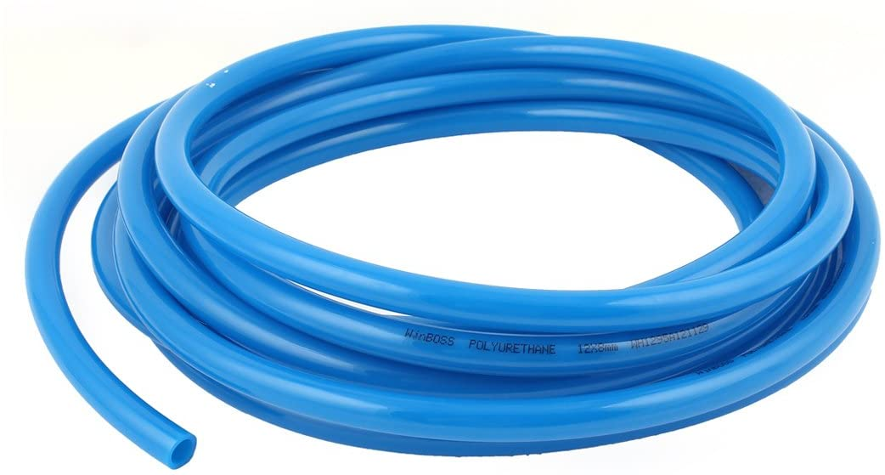

Fig. 4.2: Hose pipe Structure

**EXPERIMENTAL SETUP**

**NOZZLE**

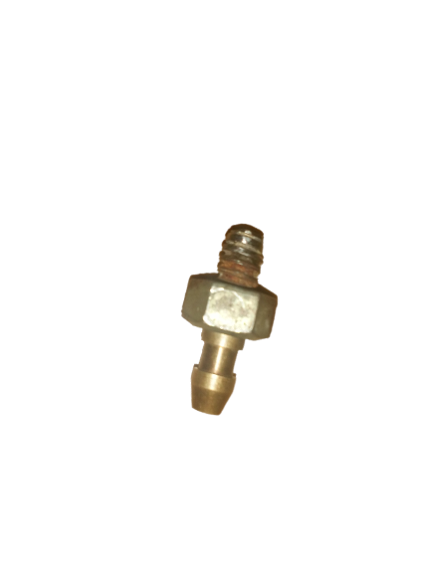

Fig. 4.3: Nozzle

**MIXING CHAMBER HOPPER**

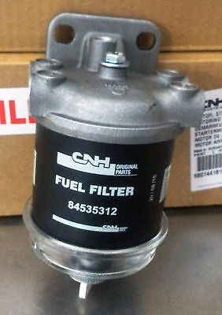

Fig. 4.4: Mixing Chamber

**4.7 VALVE**

valve is a device that regulates, directs or controls the flow of a fluid (gases, liquids, fluidized solids, or slurries ) by opening, closing, or partially obstructing various passageways. Valves are technically fittings , but are usually discussed as a separate category. In an open valve, fluid flows in a direction from higher pressure to lower pressure. The word is derived from the Latin valva , the moving part of a door, in turn from volvere , to turn, roll. Work holding refers to any device that is used to a secure a work piece and hold it in place against the forces of machining.

**4.10 AC MOTOR**

AC motor an industrial type of AC motor with electrical terminal box at the top and output rotating shaft on the left. Such motors are widely used for pumps, blowers, conveyors and other industrial machinery. An AC motor is an electric motor driven by an alternating current (AC). The AC motor commonly consists of two basic parts, an outside stationary stator having coils supplied with alternating current to produce a rotating magnetic field, and an inside rotor attached to the output shaft producing a second rotating magnetic field. The rotor magnetic field may be produced by permanent magnets, reluctance saliency, or DC or AC electrical windings. Less commonly, linear AC motors operate on similar principles as rotating motors but have their stationary and moving parts arranged in a straight line configuration, producing linear motion instead of rotation.

**CHAPTER 5**

**5 DESIGN CALCULATION**

**5.1 CALCULATION FOR NOZZLE\**

=+

1.7=1+

0.7=

m/s

**MACH NUMBER**

=0.97

**AREA MACH NUMBER RELATION**

=)

=)

=)

(1+0.188)  
 =1.0628 (0.8331.188

=1.06280.939

1

**5.2 CALCULATION FOR VOLUME FOR MIXING CHAMBER**

Density of silicon carbide =1.3gm/cc

Assume 100gm abrasive particle stored in hopper

Volume of cylinder =

=

=76.92cc

**5.3 CALCULATION FOR TWISTING MOMENT**

FOR MOTOR

P=0.5 kw N=1200 rpm

T=3.97 N-m

**CHAPTER 6**

**BLOCK DIAGRAM**

ABRASIVE POWDER

NOZZLE

WORK PIECE

MOTOR

SPINDLE

MIXING CHAMBER

COMPRESSOR

NOZZLE

PRESSURE REGULATOR

WORK PIECE

SPINDLE

MOTOR

**CREO MODEL**

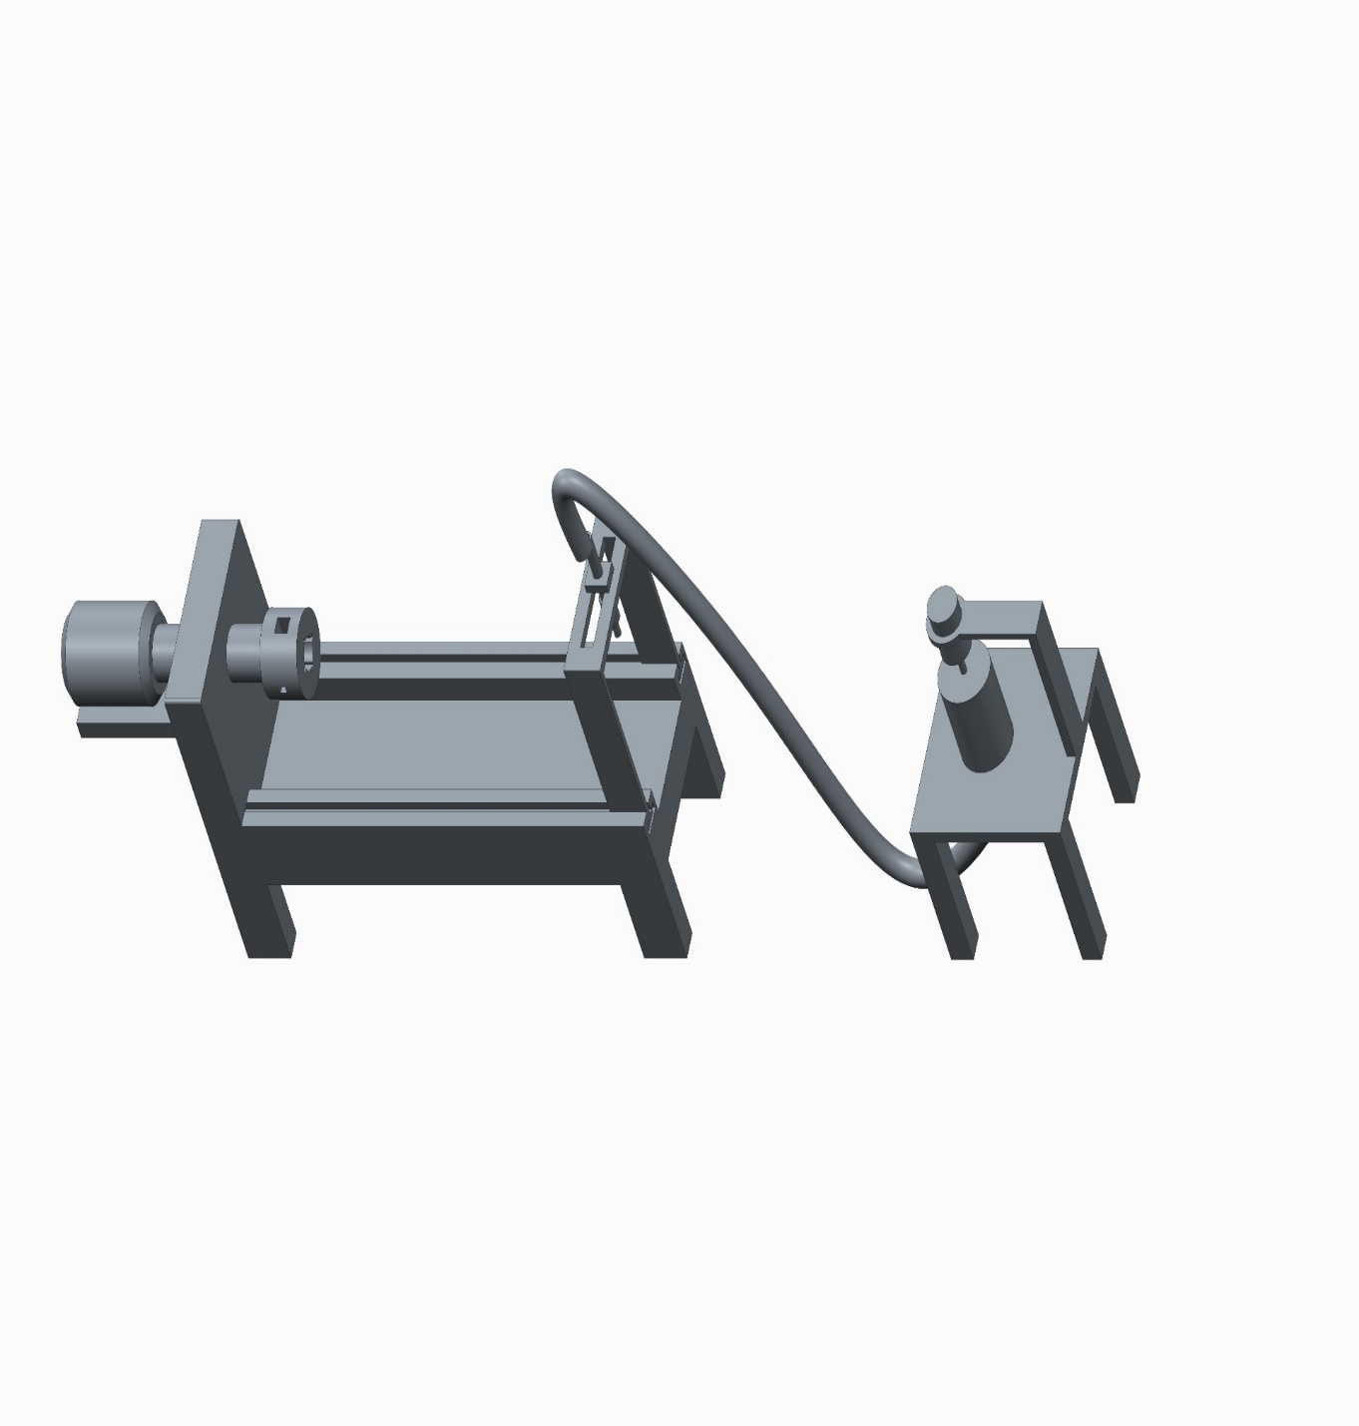

**COMPLETE SETUP**

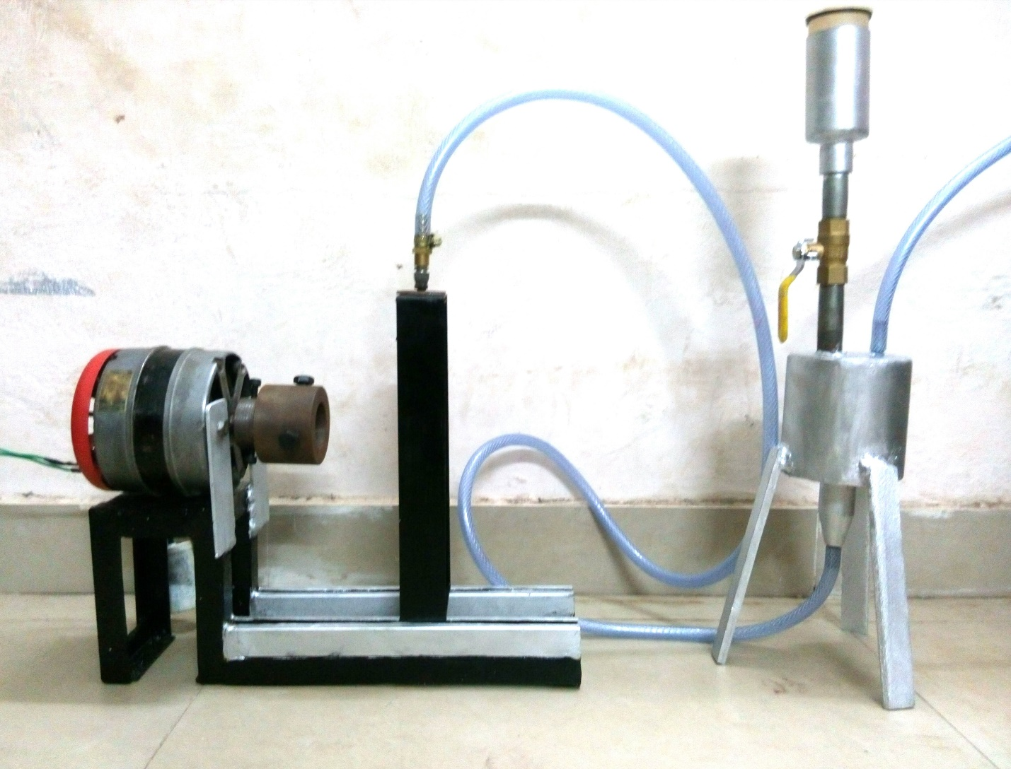

**CHAPTER 7**

**RESULT**

The abrasive jet turning machine prototype was finaly fabricated after designing, the prototypehas following advantages.

* Cutting tool is eliminated
* Frequent sharpening or grinding is not required.
* Polishing of glass and fibre tubes or rods.
* Drilling operation is performed on glass and fibre tubes or rods.

**APPLICATION:**

* **Glass product manufacturing industries**
* **Automobile industry**
* **Aerospace industry**

**CHAPTER 8**

**COST ESTIMATION**

The following table shows the detailed cost analysis of the abrasive jet turning machine prototype after fabrication,

**Table 8.1 Cost Estimation**

|  |  |
| --- | --- |
| **MATERIAL** | **AMOUNT** (in Rs.) |
| Base Structure | 500 |
| Nut and Bolts | 30 |
| Air jet pipe with nozzle | 750 |
| Abrasive Chamber | 1500 |
| Holding Device | 600 |
| Hand Valve | 170 |
| Motor | 600 |
| Lathe setup | 400 |
| Abrasive powder | 350 |
| **Total** | **4900** |

**CHAPTER 9**

**CONCLUSION**

In this project, a complete model of abrasive jet machine is fabricated in the institute laboratory. Before fabrication a complete CAD model was prepared for optimum use of material and space. Most of the components are made locally and sophisticated parts which affect the accuracy greatly are procured from outside. This greatly reduces human effort and improves accuracy.

In the present work, the process is executed only for surface removal. This work can be extended for machining materials like glass and plastics .Also in these work parameters like pressure can be increased and the mixing chamber size can be increased so that abrasives can be stored in large amount and it can be machined for longer time.

**REFERENCES**

1. Residual stress and tribological characteristics of ground surface after abrasive jet restricted by grinding wheel

Authors: Liu, F., Gong, Y.‐D., Shan, Y.‐Q., Cai, G.‐Q.

Publication: Journal of Northeastern University**,** Volume 30, Issue 3, Pages 422‐425 March 2009.

2. Simulation and analysis of abrasive jet machining with wheel restriction in grinding

Authors: Wang, W.S., Zhu, L.D., Yu, T.B., Yang, J.Y., Tang, L.

Publication: Key Engineering Materials, Volume 389‐390, Pages 387‐391, 2009

3. Abrasive water jet turning—An efficient method to profile and dress grinding wheels

Authors: D.A. Axinte, J.P. Stepanian, M.C. Kong, J. McGourlay

*Publication: International Journal of Machine Tools and Manufacture*, *Volume 49, Issues 3‐4*, *March 2009*, *Pages 351‐356* Date: Dec, 2008

4. Modeling and simulation for material removal in abrasive jet precision finishing with wheel as restraint.

Authors: Li, C.H., Ding, Y.C., Lu, B.H.

Publication: Proceedings of the IEEE International Conference on Automation and Logistics, ICAL 2008, Article number 4636666, Pages 2869‐2873, 2008

5. Abrasive jet micro‐machining of planar areas and transitional slopes

Authors: Ghobeity, A.; Spelt, J. K.; Papini, M.

Publication: *Journal of Micromechanics and Microengineering*, Volume 18, Issue 5, pp. 055014., 2008

6. Three‐Dimensional CFD Simulation of Two phase Flow Inside the Abrasive Water Jet Cutting Head

Authors: Umberto Prisco; Maria Carmina D'Onofrio.

Publication: *International Journal of Computational Methods in Engineering Science and Mechanics* 9 (5), pp. 300‐319 , 2008

7. Machinability of glass by abrasive waterjet

Authors: Zhu, H.T., Huang, C.Z., Wang, J., Lu, X.Y. and Feng, Y.X.

Publication: International Journal of Materials and Product Technology, Vol. 31, No.1, pp.106–112, 2008.

8. Surface evolution models for abrasive jet micromachining of holes in glass and polymethylmethacrylate (PMMA)

Authors: Ghobeity, A.; Getu, H.; Papini, M.; Spelt, J. K.

Publication: *Journal of Micromechanics and Microengineering*, Volume 17, Issue 11, pp. 2175‐2185 (2007).

Date: 11/2007

9. Surface Roughness of Carbides Produced by Abrasive Water Jet Machining

Authors: Khan, Ahsan Ali; Awang, Mohd Efendee Bin; Annuar, Ahmad Azwari Bin

Publication: *Journal of Applied Science*, vol. 5, Issue 10, p.1757‐1761

Date: 06/2005

10. A Study on Abrasive Water Jet Machining of Aluminum with Garnet Abrasives.

Authors: Khan, Ahsan Ali; Munajat, Noraziaty Bt.; Tajudin, Harnisah Bt.

Publication: *Journal of Applied Science*, vol. 5, Issue 9, p.1650‐1654